



K-Means Clustering

LAB MANUAL

Disclaimer: The content is curated from online/offline resources and used for educational purpose only
Customer Segmentation Using K-Means Clustering on Spending Patterns in an Indian Retail Dataset

Objective:
To perform customer segmentation using K-Means clustering based on spending patterns in the Indian retail dataset.

Problem Statement:
In a competitive retail environment, understanding customer behavior is essential for personalized marketing and business growth. This lab focuses on segmenting customers in an Indian retail dataset based on their spending patterns using the K-Means clustering algorithm. The goal is to identify distinct customer groups to support data-driven strategies such as targeted promotions, loyalty programs, and inventory planning. The clustering model will analyze features like annual income, spending score, and other relevant variables to uncover hidden patterns and group similar customers together. The results will be visualized to interpret the characteristics of each segment.

Equipment Required:
- Python installed with Jupyter Notebook / VS Code / Google Colab
- Libraries: pandas, numpy, matplotlib, seaborn, scikit-learn
- Dataset: Indian retail dataset containing customer spending-related features such as CustomerID, Annual Income, Spending Score, Age, Gender, or other demographic and transactional information

Prerequisites:
- Basic knowledge of Python
- Understanding of clustering techniques, particularly K-Means
- Familiarity with Pandas, NumPy, Matplotlib, Seaborn, and Scikit-Learn libraries

Dataset Description:
The dataset contains retail sales and customer demographic details. The key features include:
- Transaction ID – Unique identifier for transactions.

- Date – Date of the transaction.
- Customer ID – Unique identifier for customers.
- Gender – Gender of the customer (Male/Female).
- Age – Age of the customer.
- Product Category – Category of the purchased product.
- Quantity – Number of units purchased.
- Price per Unit – Cost per unit of the product.
- Total Amount – Total amount spent in the transaction.

Procedure:
Step 1: Import Necessary Libraries
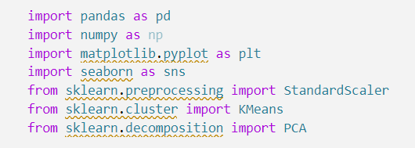

Step 2: Load and Explore the Dataset
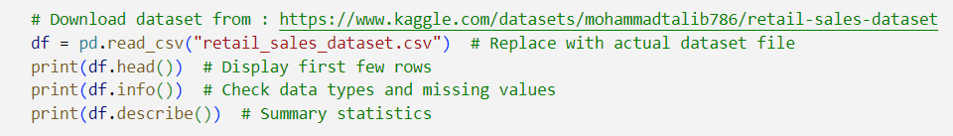
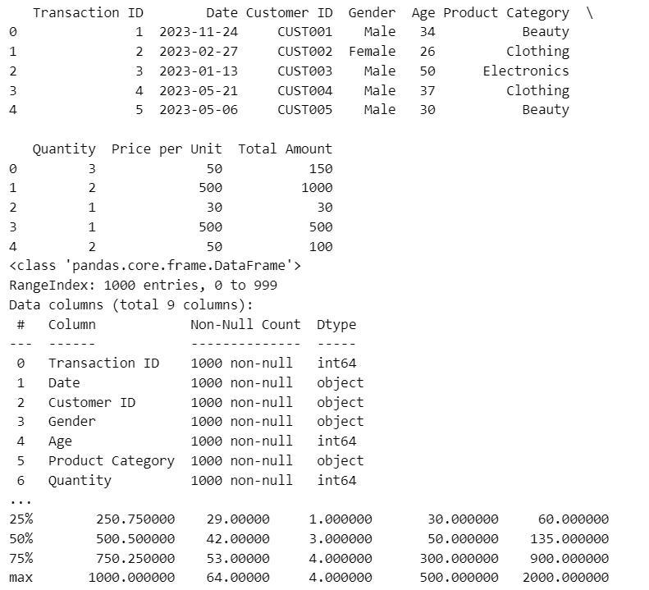

Step 3: Data Preprocessing
- Handle missing values if any.
- Select relevant features for clustering.
- Normalize numerical values for better clustering.

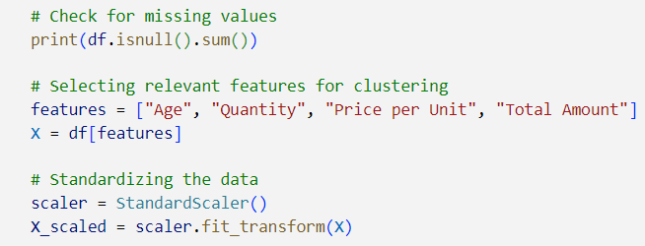

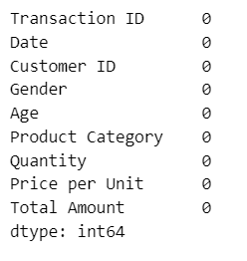

Step 4: Determine Optimal Number of Clusters (Elbow Method)

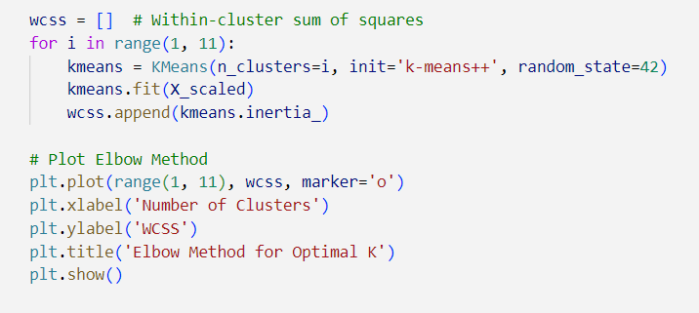
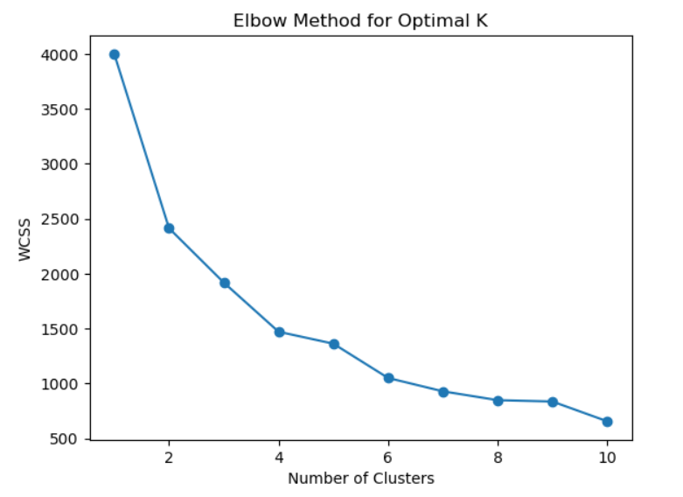

Step 5: Apply K-Means Clustering
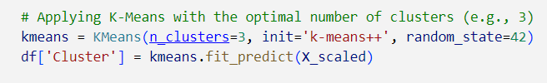

Step 6: Visualizing Clusters using PCA
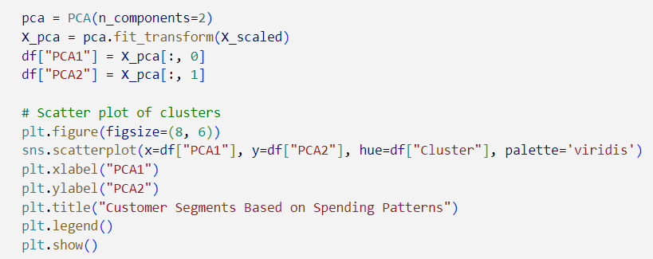

Output:
